Pure Mathematics

🌟 Definition
# Source: AI Source: Provided by: [Data Path: Persons Table -> ID Column: 1, Name_En Column: Motasem Essam] -> From: [ChatGPT] on [5/30/2026]
Pure Mathematics is the branch of mathematics that studies abstract mathematical objects, structures, patterns, and theories for the purpose of understanding mathematics itself, without requiring immediate practical applications.
It focuses on discovering and developing mathematical knowledge through logical reasoning and proof.

🎯 Purpose of Pure Mathematics
# Source: AI Source: Provided by: [Data Path: Persons Table -> ID Column: 1, Name_En Column: Motasem Essam] -> From: [ChatGPT] on [5/30/2026]
- To develop mathematical theories
- To understand abstract structures and patterns
- To discover new mathematical relationships
- To establish rigorous proofs
- To expand mathematical knowledge

📚 Main Divisions of Pure Mathematics

1. Quantity
# Source: AI Source: Provided by: [Data Path: Persons Table -> ID Column: 1, Name_En Column: Motasem Essam] -> From: [ChatGPT] on [5/30/2026]
Studies numbers, quantities, and numerical relationships.
Main Branches
- Arithmetic
- Number Theory
Example
$$15+10=25$$

2. Structure
# Source: AI Source: Provided by: [Data Path: Persons Table -> ID Column: 1, Name_En Column: Motasem Essam] -> From: [ChatGPT] on [5/30/2026]
Studies patterns, algebraic systems, and mathematical structures.
Main Branches
- Algebra
- Linear Algebra
- Abstract Algebra
- Group Theory
- Ring Theory
- Field Theory
Example
$$a+b=b+a$$

3. Space
# Source: AI Source: Provided by: [Data Path: Persons Table -> ID Column: 1, Name_En Column: Motasem Essam] -> From: [ChatGPT] on [5/30/2026]
Studies shapes, dimensions, positions, and geometric properties.
Main Branches
- Euclidean Geometry
- Analytic Geometry
- Differential Geometry
- Topology
- Trigonometry
Example
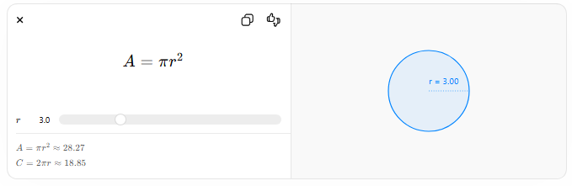
$$A=πr^{2}$$
$$r$$
$$A=πr^{2}≈28.27$$
$$C=2πr≈18.85$$
r = 3.00

4. Change
# Source: AI Source: Provided by: [Data Path: Persons Table -> ID Column: 1, Name_En Column: Motasem Essam] -> From: [ChatGPT] on [5/30/2026]
Studies variation, motion, and continuously changing quantities.
Main Branches
- Calculus
- Mathematical Analysis
- Differential Equations
- Dynamical Systems
Example
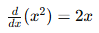
$$\frac{d}{dx}(x^{2})=2x$$

🧩 What Pure Mathematics Studies
# Source: AI Source: Provided by: [Data Path: Persons Table -> ID Column: 1, Name_En Column: Motasem Essam] -> From: [ChatGPT] on [5/30/2026]
Pure mathematics studies:
- Mathematical objects
- Numbers
- Sets
- Functions
- Geometric figures
- Algebraic structures
- Mathematical statements
- Proofs
- Theorems
- Abstract relationships

🔗 Relationship to Other Mathematical Fields
# Source: AI Source: Provided by: [Data Path: Persons Table -> ID Column: 1, Name_En Column: Motasem Essam] -> From: [ChatGPT] on [5/30/2026]
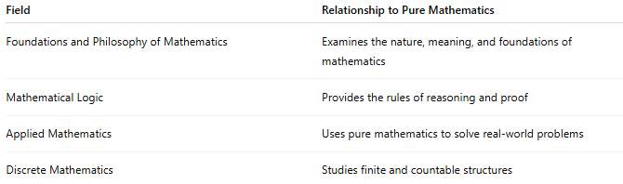
Field | Relationship to Pure Mathematics
Foundations and Philosophy of Mathematics | Examines the nature, meaning, and foundations of mathematics
Mathematical Logic | Provides the rules of reasoning and proof
Applied Mathematics | Uses pure mathematics to solve real-world problems
Discrete Mathematics | Studies finite and countable structures

✏️ Example Questions
# Source: AI Source: Provided by: [Data Path: Persons Table -> ID Column: 1, Name_En Column: Motasem Essam] -> From: [ChatGPT] on [5/30/2026]
- What properties do prime numbers have?
- Are there infinitely many prime numbers?
- What is the structure of a group?
- What properties do geometric spaces possess?
- How do functions behave under transformation?

📖 Pure Mathematics vs Applied Mathematics
# Source: AI Source: Provided by: [Data Path: Persons Table -> ID Column: 1, Name_En Column: Motasem Essam] -> From: [ChatGPT] on [5/30/2026]
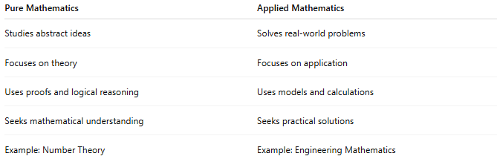
Pure Mathematics | Applied Mathematics
Studies abstract ideas | Solves real-world problems
Focuses on theory | Focuses on application
Uses proofs and logical reasoning | Uses models and calculations
Seeks mathematical understanding | Seeks practical solutions
Example: Number Theory | Example: Engineering Mathematics

🧠 Simple Analogy
# Source: AI Source: Provided by: [Data Path: Persons Table -> ID Column: 1, Name_En Column: Motasem Essam] -> From: [ChatGPT] on [5/30/2026]
Pure mathematics is like exploring a new world of ideas:
- The goal is to understand the world itself.
- Practical applications may come later.
- The focus is discovery, structure, and truth.

🧭 Summary
# Source: AI Source: Provided by: [Data Path: Persons Table -> ID Column: 1, Name_En Column: Motasem Essam] -> From: [ChatGPT] on [5/30/2026]
Pure Mathematics is the study of abstract mathematical concepts, structures, patterns, and theories. It seeks to understand mathematics itself through logic, definitions, axioms, proofs, and theorems, forming the theoretical foundation for all other branches of mathematics.

